# LMM and GLMM model comparisons

**ITA DATASET**

Comparisons of the model 0s for LMM with inverse transformation, without and with glmm a la Lo and Adrews (2015):

* italmer0 <- lmer(-1000/rt ~ 1 + (1|subject) + (1|target), data= dataIta, REML = F); **model 0 LMM with -1000/rt**
* italmer0a <- lmer(rt ~ 1 + (1|subject) + (1|target), data= dataIta, REML = F); **model 0 LMM with raw rt**
* itaglmer0<- glmer(rt ~ 1 + (1|subject) + (1|target), data= dataIta, family=Gamma(link="identity")); **model 0 GLMM**
* **Model comparisons with AIC and BIC:**

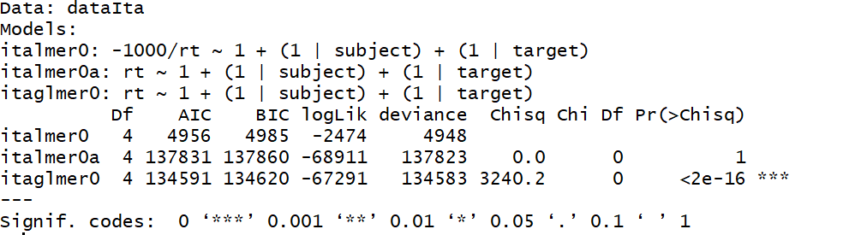

* **It’s clear that the best AIC is the model we used with -1000/rt compared to without inverse transformation, and compared also with the glmm model.**
* italmer2 <- lmer(-1000/rt ~ relatedness * morphType + freqTarget + (1|subject) + (1|target), data= dataIta, REML = T); **LMM with the variables of interest -1000/RT**

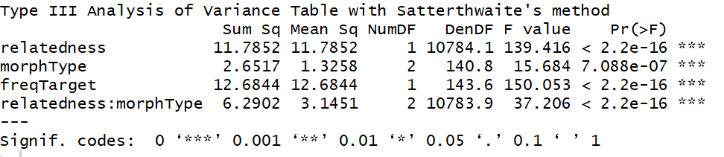

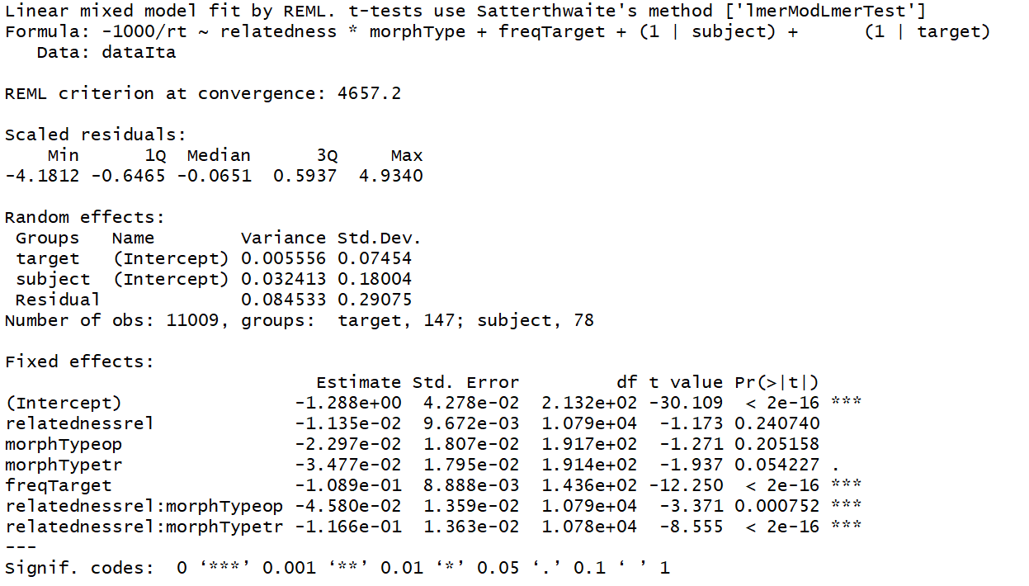

* italmer2a <- lmer(rt ~ relatedness * morphType + freqTarget + (1|subject) + (1|target), data= dataIta, REML = T); **LMM with the variables of interest raw RT**

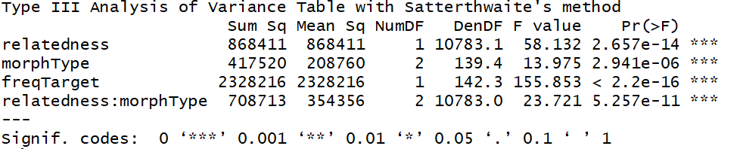

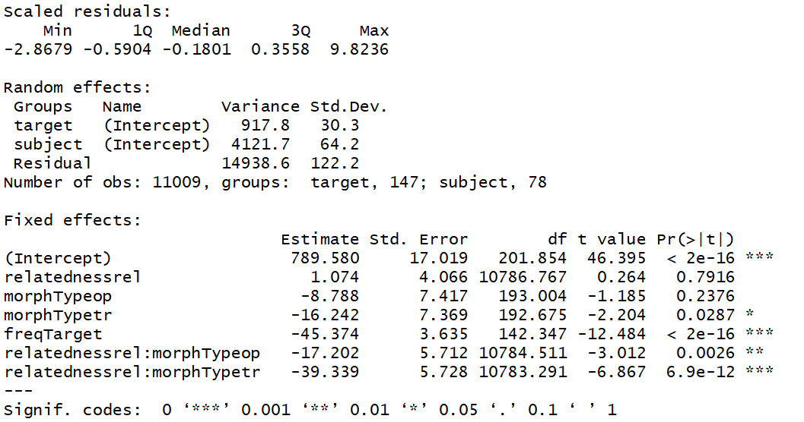

* italmer2b <- lmer(-1000/rt ~ relatedness * morphType + freqTarget + (1|subject) + (1|target), data=subset(dataIta, abs(scale(resid(italmer2)))<2.5), REML = T); **LMM with the variables of interest -1000/RT with TRIMMING**

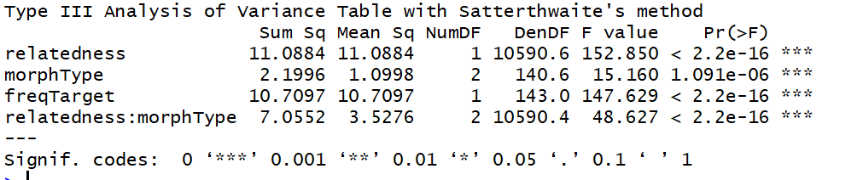

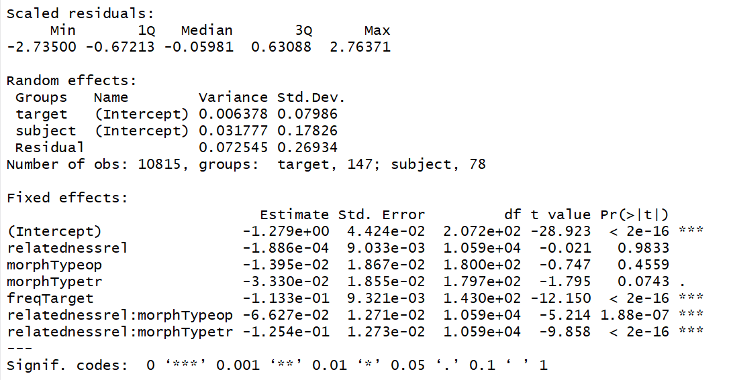

* itaglmer2<- glmer(rt ~ relatedness * morphType + freqTarget + (1|subject) + (1|target), data= dataIta, family=Gamma(link="identity")); **GLMM with the variables of interest raw RT**

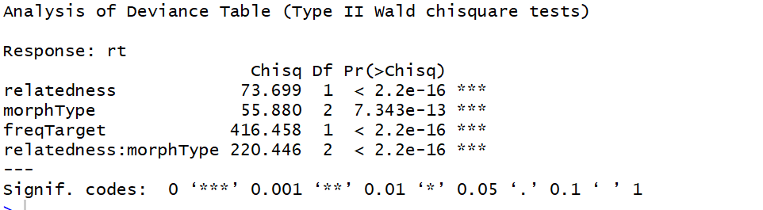

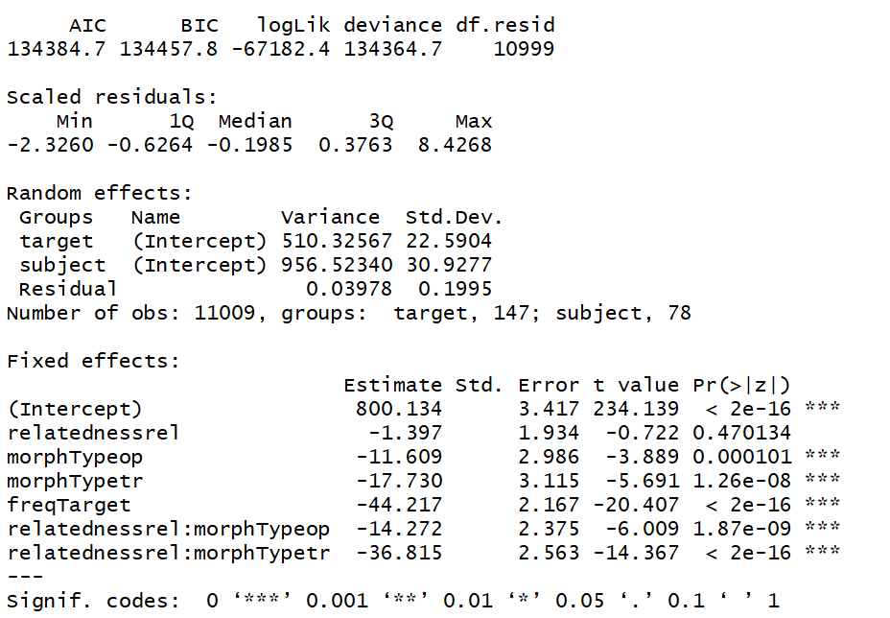

* **model comparisons:**

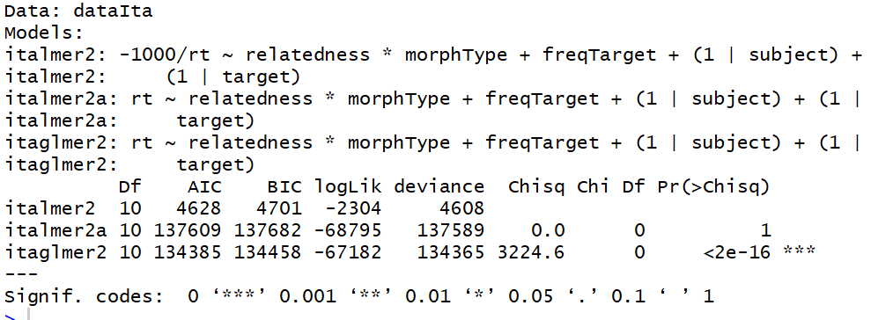

* **Our initial model used in the paper has the lowest AIC**

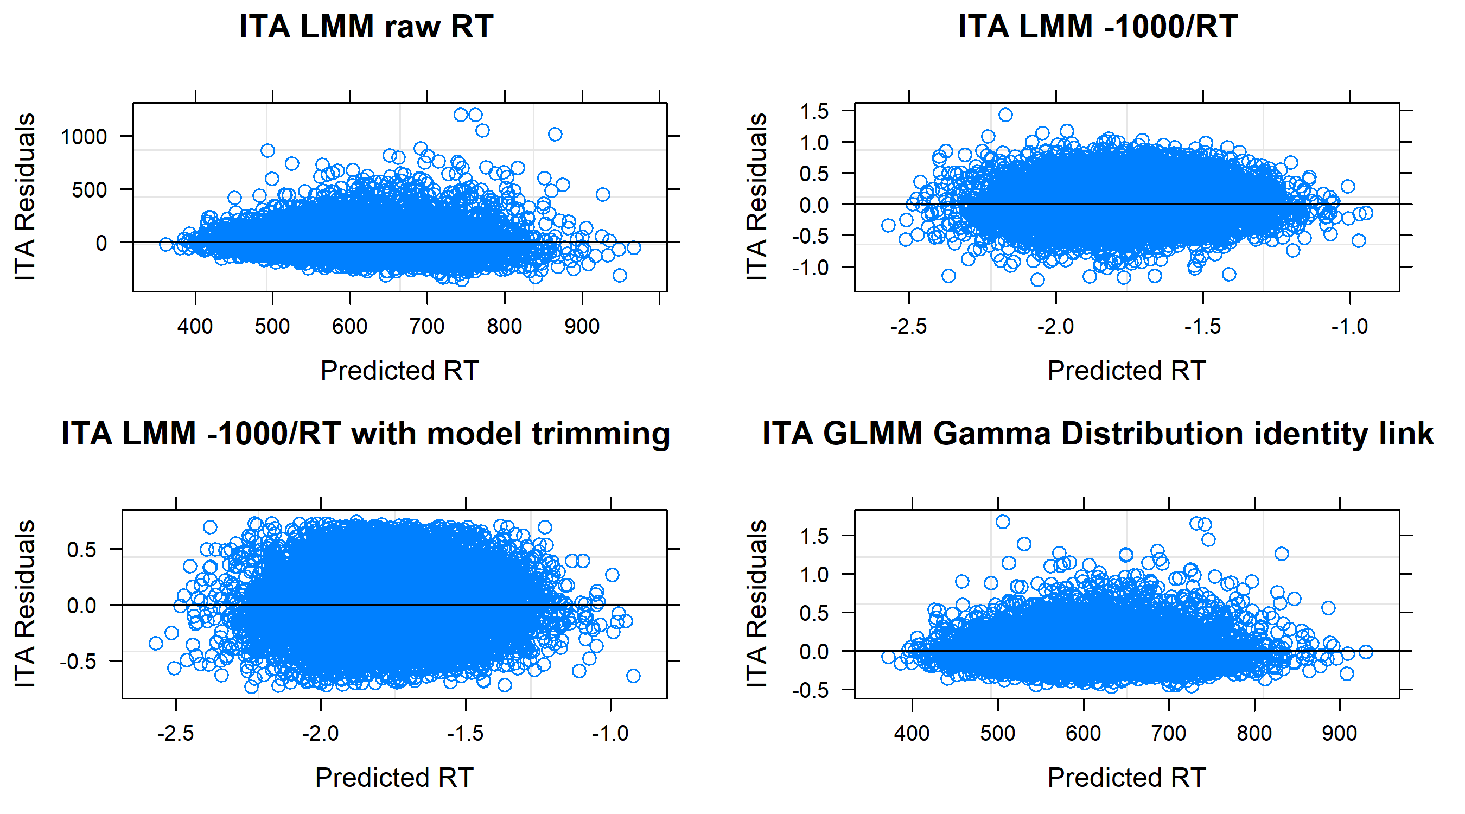

**ENG DATASET**

* englmer0 <- lmer(-1000/rt ~ 1 + (1|subject) + (1|target), data= dataEng, REML = F); **model 0 LMM -1000/RT**
* englmer0a <- lmer(rt ~ 1 + (1|subject) + (1|target), data= dataEng, REML = F); **model 0 LMM raw RT**
* engglmer0 <- glmer(rt ~ 1 + (1|subject) + (1|target), data = dataEng, family=Gamma(link="identity")); **model 0 GLMM**

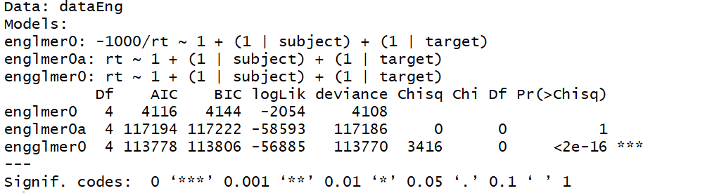

* englmer2 <- lmer(-1000/rt ~ relatedness * morphType + freqTarget + lengthTarget + (1|subject) + (1|target), data= dataEng, REML = T); **LMM with the variables of interest -1000/RT**

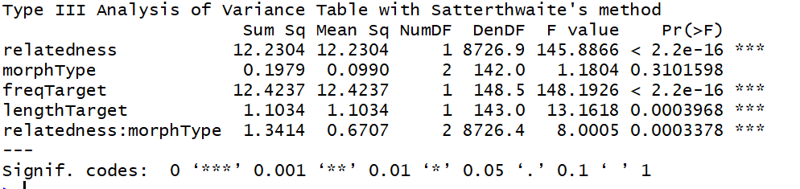

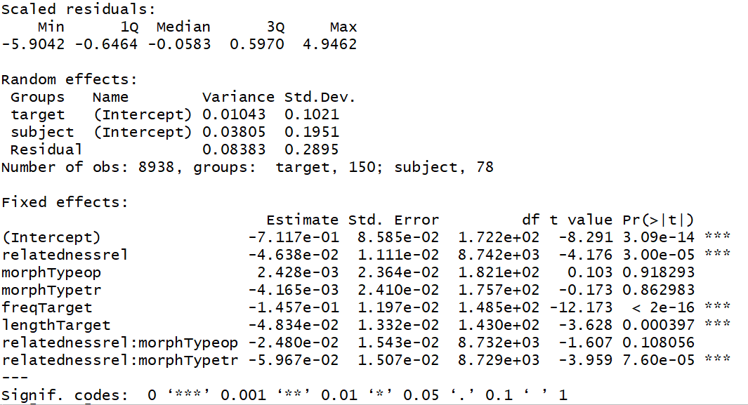

* englmer2a <- lmer(rt ~ relatedness * morphType + freqTarget + lengthTarget + (1|subject) + (1|target), data= dataEng, REML = T); **LMM with the variables of interest raw RT**

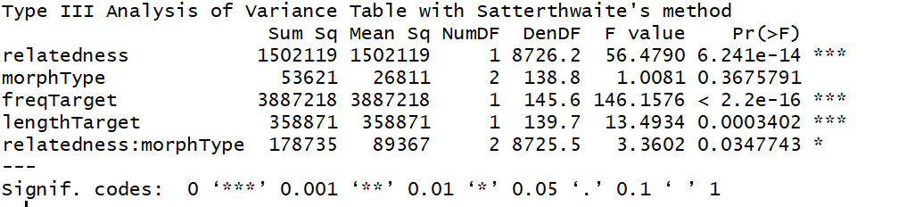

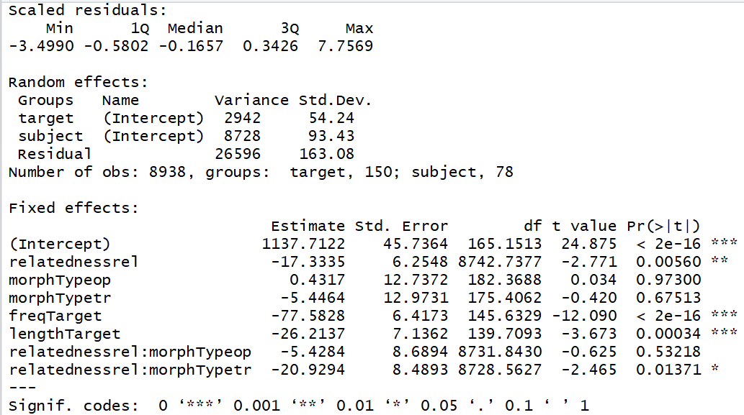

* engglmer2 <- glmer(rt ~ relatedness * morphType + freqTarget + lengthTarget + (1|subject) + (1|target), data = dataEng, family=Gamma(link="identity")); **GLMM with the variables of interest**

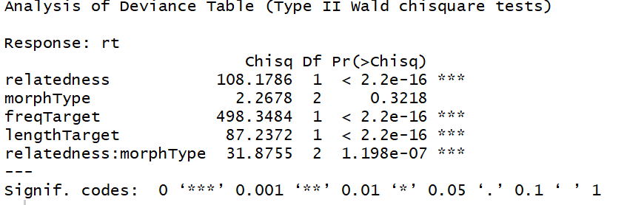

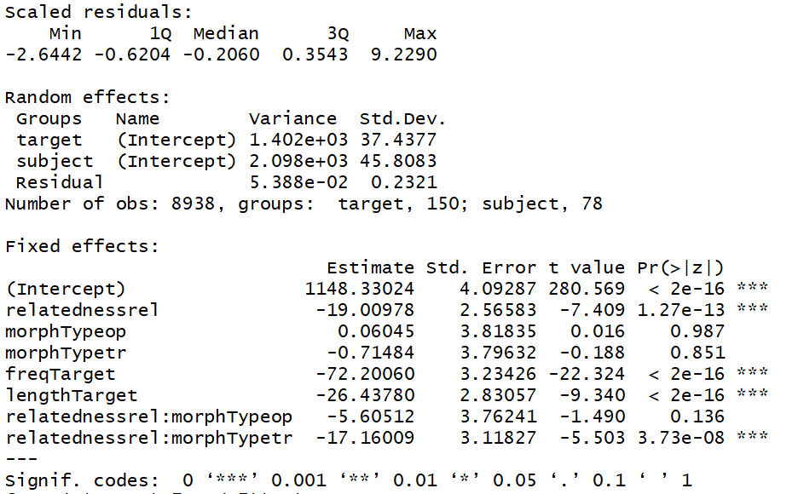

* **model comparisons:**

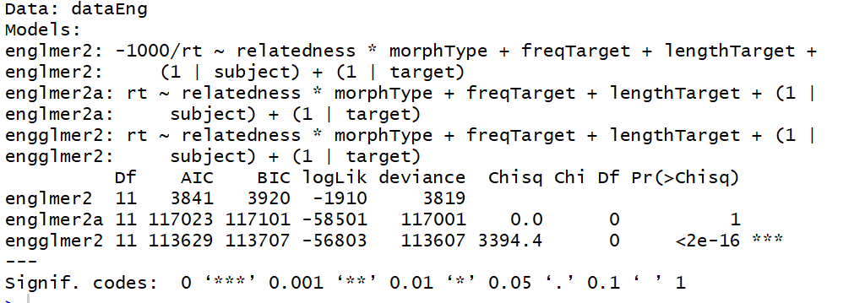

* englmer2b <- lmer(-1000/rt ~ relatedness * morphType + freqTarget + lengthTarget + (1|subject) + (1|target), data=subset(dataEng, abs(scale(resid(englmer2)))<2.5), REML = T); **LMM with the variables of interest -1000/RT with TRIMMING**

